# Tableau Public

# Visualization-1

Overview of Data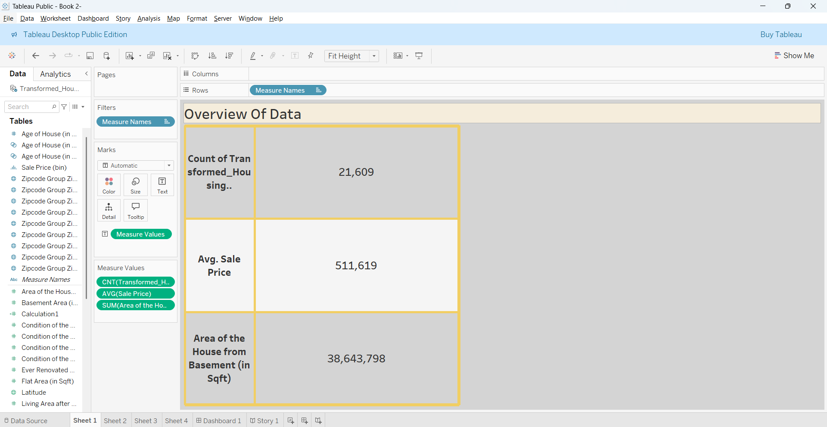

Visualization-2

Total Sales by Years Since Renovation

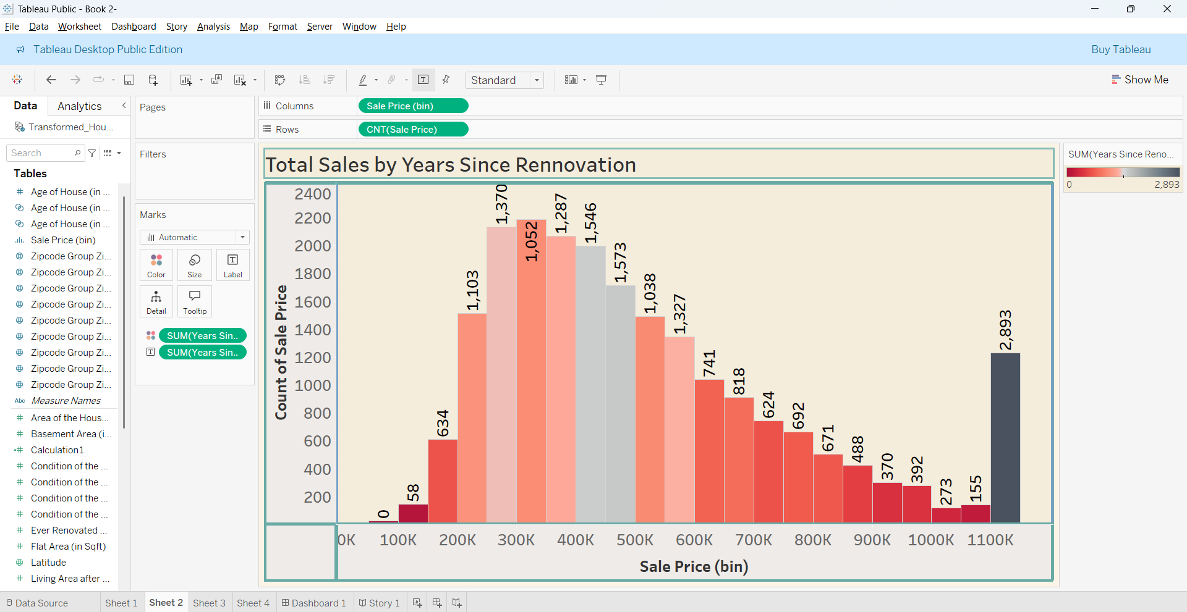

Visualization-3

Distribution of House Age by Renovation Status

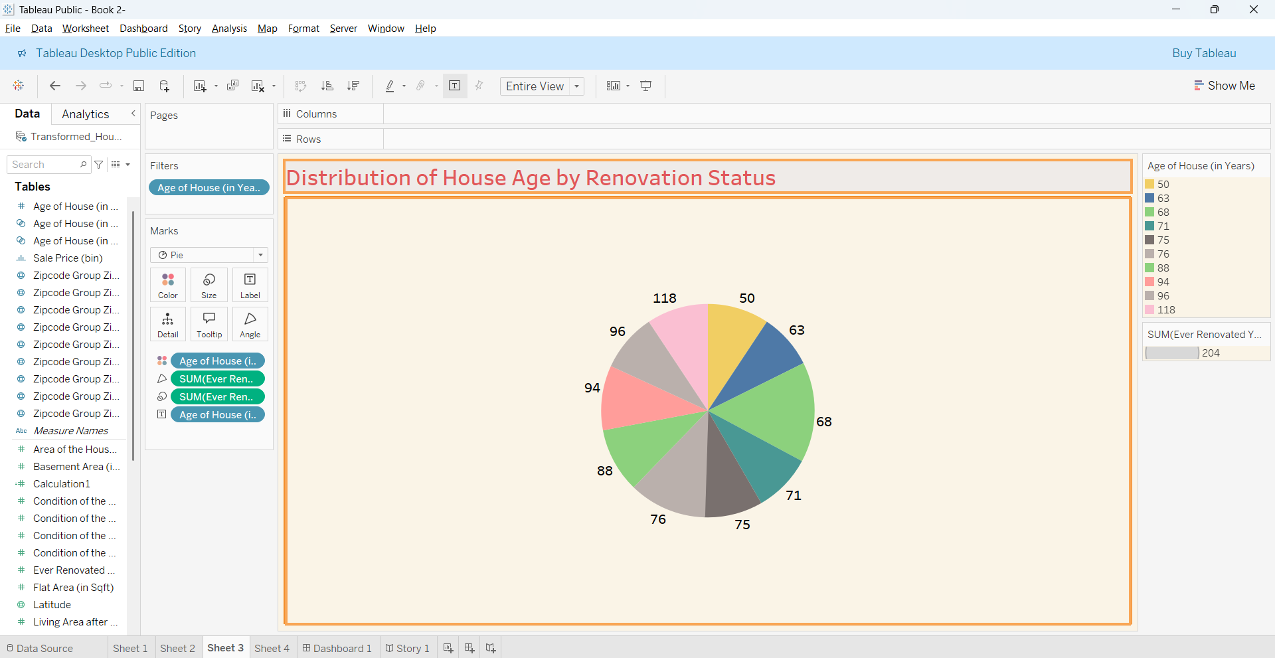

Visualization-4

Distribution by Bathrooms,Bedrooms,Floors

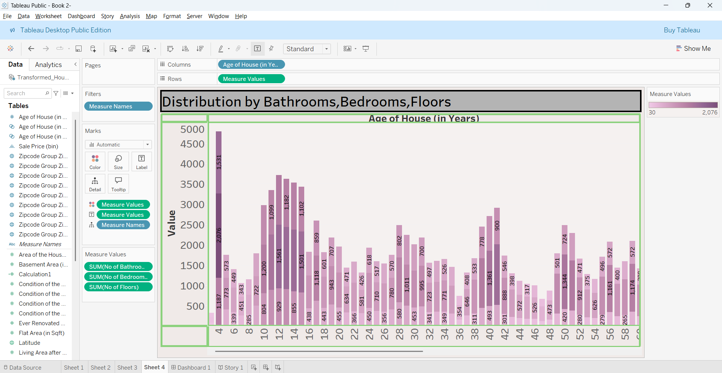

Dashboard

